PROJECT DISSEMINATION

NAME OF PARTNER | Escola Sant Josep
NAME OF THE DISSEMINATION ACTIVITY | Online meeting with Play & Grow team
DATE | 13th Jaunary 2025
EVIDENCES ( SCREENSHOT) | 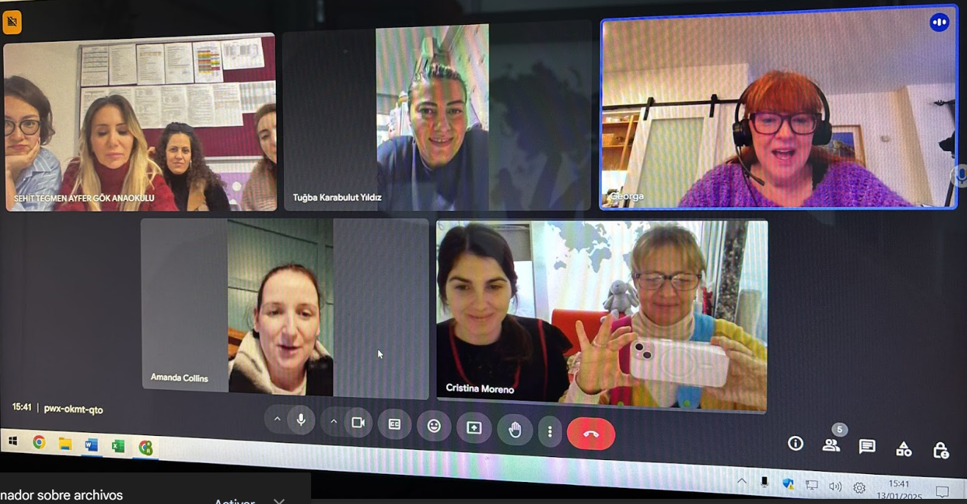
DESCRIBE THE IMPLEMENTED DISSEMINATION ACTIVITY  &  PHOTOS | Judith and Àngels had a meeting with partners of the Eramus+ project to meet and greet and begin planning.
LANGUAGE | English
LOCATION (COUNTRY&REGION) | Escola Sant Josep, TERRASSA (Spain)
PARTICIPANTS / TARGET AUDIENCE(S) | - Sunay-Gönül-T¨rkan-Saadet Saygan Kardesler 5 Abaokulu (TÜRKIYE)  - Sehit Tegmen Ayfer Gok Anaokulu (TÜRKIYE)  - Child’s Play Early Education Company Llimited (IRLEAND)  - Sant Josep School (TERRASSA)
NUMBER OF PARTICIPANTS / TARGET AUDIENCE(S) | 9
INTERNET ADDRESS (if applicable) | No

