PROJECT DISSEMINATION

NAME OF PARTNER | Escola Sant Josep
NAME OF THE DISSEMINATION ACTIVITY | Online meeting with Play & Grow team
DATE | 21th February2025
EVIDENCES ( SCREENSHOT) | 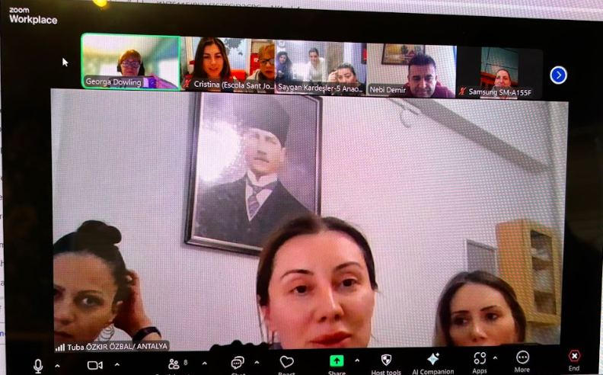
DESCRIBE THE IMPLEMENTED DISSEMINATION ACTIVITY  &  PHOTOS | Review emotions activity and share information, decide on next steps.  - We all shared how we carried out the activities with the children. We shared the process and the drawings that the children did.  - We will use some of these drawings, or icons within the drawings, to create our logo. We agreed that each country would look at the drawings from each country and pick an element from each country to put into canva or AI to create a logo. We would share these over the next 2 weeks and choose one for our project.  - We agreed that before we carry out anything else, to ensure quality, we need to learn more and increase our knowledge. We reviewed a project outline working document and decided to work on points 1.5 and 1.6 over the next 2 weeks. These are: 1.5: Analysis of the curriculum: Ireland, Spain and Turkey. 1.6: Strategies used for supporting children  For 1.5: Analysis of the curriculum: Ireland, Spain and Turkey – each country will review the curriculum and policies in their country and see where trauma and supports for trauma is mentioned for children aged 3 – 5 years.  For 1.6: Strategies used for supporting children: each country will look at the supports and strategies that are suggested within regulations and policies to use when supporting children with trauma.  - It was agreed that all written documentation would be in English, and we would use the Harvard Referencing style when we are referencing.  - We reviewed the Google Drive so everyone knows where they need to input their evidence and the documentation.  - We agreed the next meeting would be on Friday 7th March 2025 at 10am Irish time (the same time as this meeting).
LANGUAGE | English
LOCATION (COUNTRY&REGION) | Escola Sant Josep, TERRASSA (Spain)
PARTICIPANTS / TARGET AUDIENCE(S) | - Sunay-Gönül-T¨rkan-Saadet Saygan Kardesler 5 Abaokulu (TÜRKIYE)  - Sehit Tegmen Ayfer Gok Anaokulu (TÜRKIYE)  - Child’s Play Early Education Company Llimited (IRLEAND)  - Sant Josep School (TERRASSA)
NUMBER OF PARTICIPANTS / TARGET AUDIENCE(S) | 9
INTERNET ADDRESS (if applicable) | No

